CS/EE 120B

Custom Project: Alarm Clock System

May 5, 2018

# Introduction

This Alarm clock will be implement a speaker to alarm the user to wake up, a LCD display will display the time and if the alarm is on, a motor will spin a propellor toy into the air, and a sensor will sense if the propellor toy is in the launch hole and the alarm will keep going off till the person puts the toy back into the designated launch hole. The alarm will be plugged in the wall outlet.

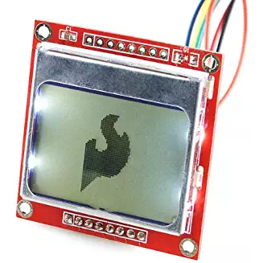

# Components (Pin-out)

* **Inputs**
  + Sensors around launcher to sense the propellor toy when stationed
  + Buttons to set the time
* **Outputs**
  + DC Motor to spin propellor
  + Speaker for noise
  + An LCD Panel for displaying time

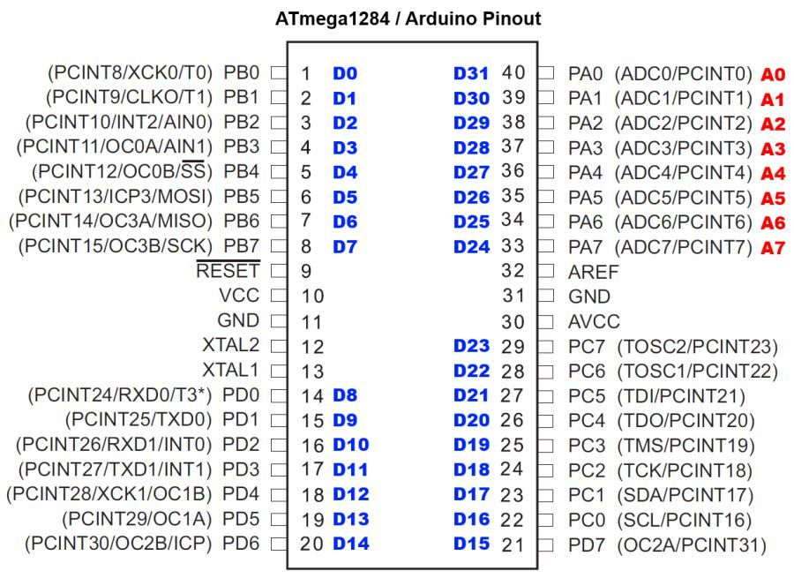

# Complexities/Build-upons

1. Using an Nokia 5110 LCD Panel to display the time and alarm on/off display.
2. Keeping Track of the Time and Saving the Alarm Data in the EEPROM so it will remember alarm data even after being turned off.
3. Using a sensor to sense if the propellor toy is in the launch hole.
4. Using a motor driver to use a motor to propel the toy.